**Test Document for One IR can be linked with One Receipt only**

Testing in Warehouse Receipts (whinh3512m000)

Testing for IR no 440904 present in R20100002 in warehouse receipts

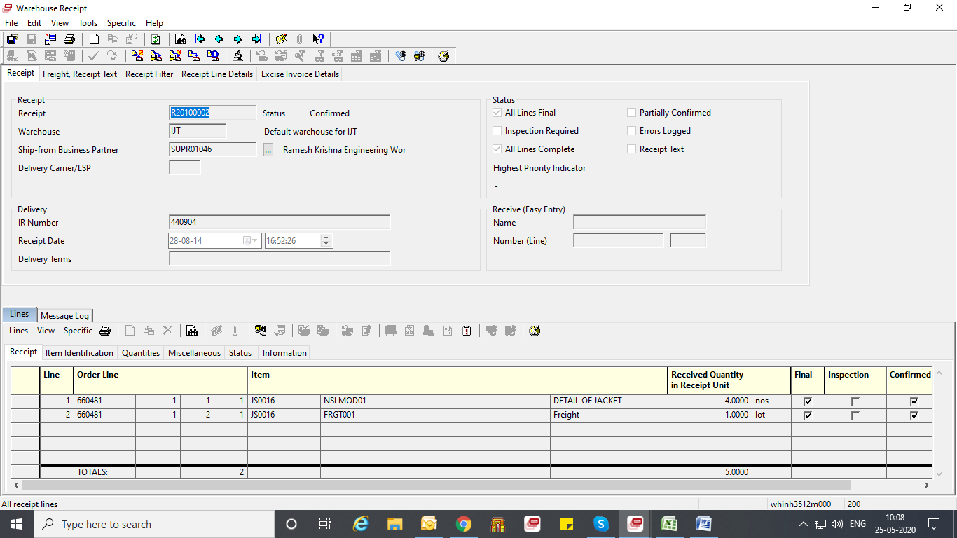

Create new record.

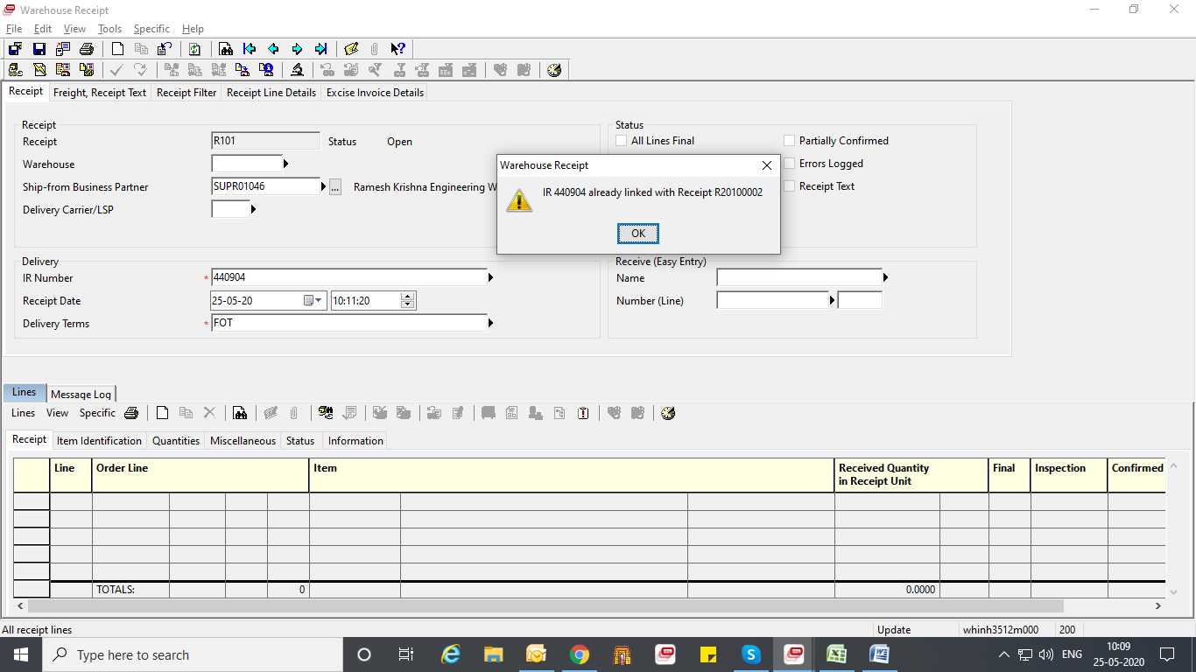

Now, test for IR no 580642 present in R82000295 in Purchase Receipts

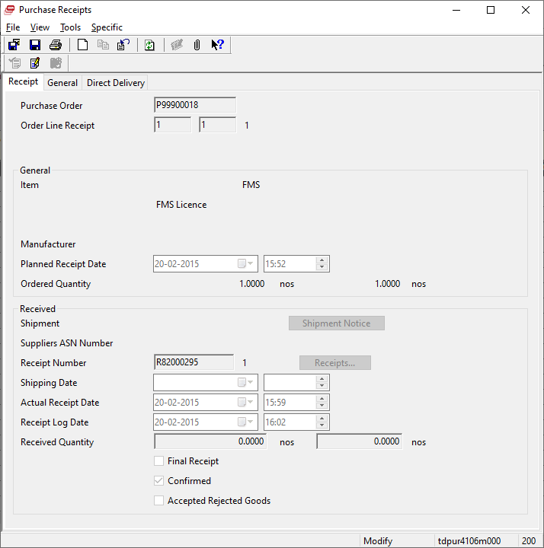

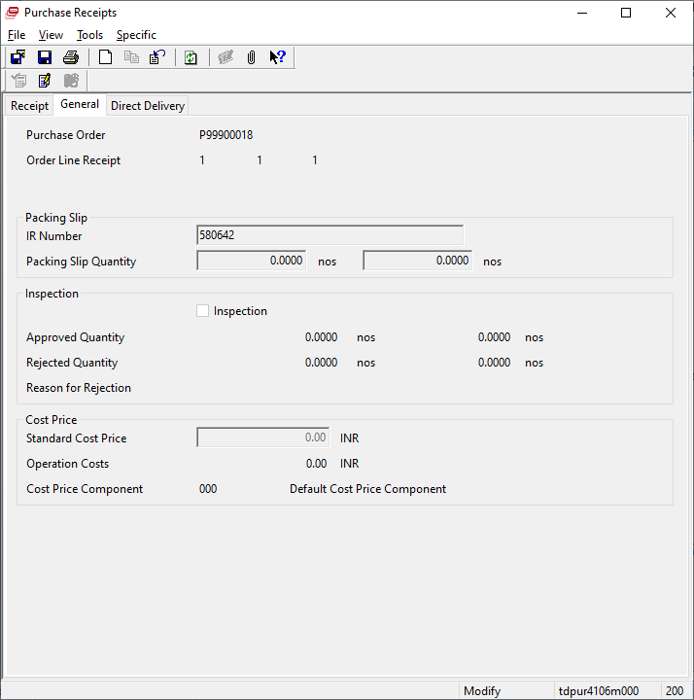

Again create new warehouse receipts, then

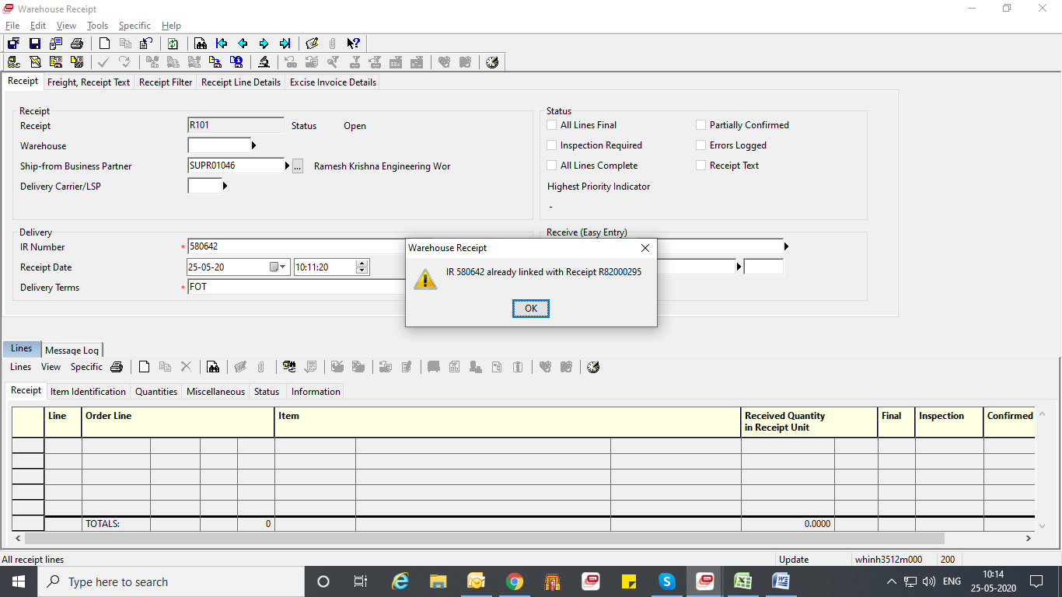

Similarly, test in Purchase receipt for same IR no,

